**HOSPITAL APPOINTMENT SYSTEM**



**Project Report**

On

**“Hospital Appointment System”**

Guided By:- Submitted By :

**Mr. Rohit Kumar Akanksha Sharma**

**Ms. Mamta Sharma**  **Ankit Jain**

|  |  |  |
| --- | --- | --- |
|  |  |  |
|  |  |  |

**TABLE OF CONTENTS**

|  |  |  |
| --- | --- | --- |
| **Chapter** | **Topic** | **Page No.** |
| **1** | **Introduction** | **3** |
| **2** | **Technologies Used** | **4** |
| **3** | **Module Information** | **5** |
| **4** | **Diagrams** | **8** |
| **5** | **Test Cases** | **13** |
| **6** | **Screenshots** | **14** |
| **7** | **Future Enhancements** | **22** |
| **8** | **Sources** | **23** |

**1. INTRODUCTION**

The proposed project is the Hospital Appointment System (HAS) which will enable patients to book as well as cancel appointments in accordance with the availability of doctors. In most of the hospitals this kind of activity is paper-based which is a slow process and cannot provide the information required within a reasonable time-frame. Hence, this project offers an effective solution where users can view various booking slots available and select the preferred date and time. This web based application overcomes the issue of managing and booking appointments.

The patient can register with system by entering their name and contact details. This account will be accessible through a Unique ID, which will be the Adhaar Card number of the user and a password. Patients can choose appointment with doctor on the available dates and mention purpose of their visit. In addition to this, the patients can view and cancel a pre-booked appointments.

**2. TECHNOLOGIES USED**

* Front End : HTML, CSS, JavaScript
* Back End : Servlets, Jsp
* Database : Oracle 10g
* Language Used : SQL
* IDE : Net beans IDE 7.0.1/ ECLIPSE IDE
* Softwares : Wamp Server, Apache Tomcat 8

**3. MODULE INFORMATION**

* **Registration :** The **H.A.S** will allow patient to register as a new user. Adhaar Card number will be the Patient ID. This ID shall be used by the patient for booking or cancelling his/her appointment
* **Login :** The user will be able to login to his account using password. In case of entering a wrong password, a dialog box will appear stating the fault in the password.
* **Booking appointments :**

**- Doctor Select :** List of Doctors will be enlisted to the user

**- Date Select :** The user will be able to select the date of appointment from a list of

available dates of the doctor

**- Description :** Patient will have to mention the purpose of his visit or the disease.

**- Confirm Booking :** Patients will confirm their appointment bookings

* **View and Cancel Appointment :**

- V**iew Appointment :** Already booked appointments can be viewed by the user.

**- Cancel appointment :** Pre-booked appointments can be cancelled.

* **Logout :** Logs out the user from his account
* **Database :** The following parameter tables will be made in the database

**- Patient Registration**

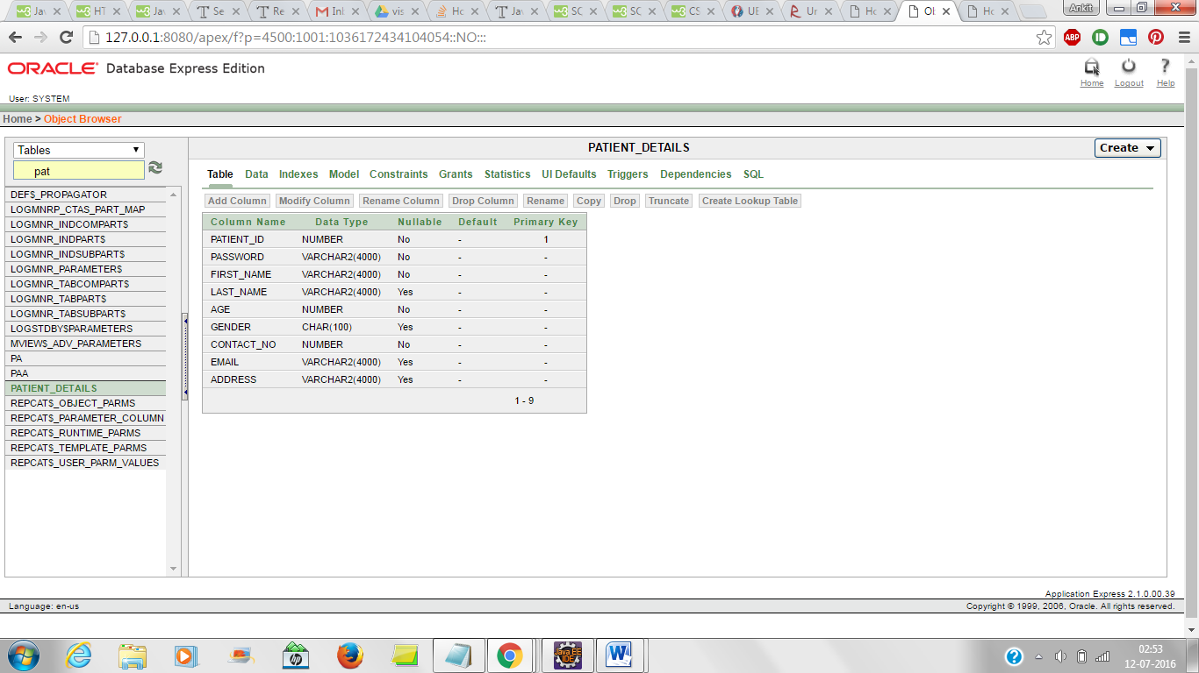

**- Doctor Registration**

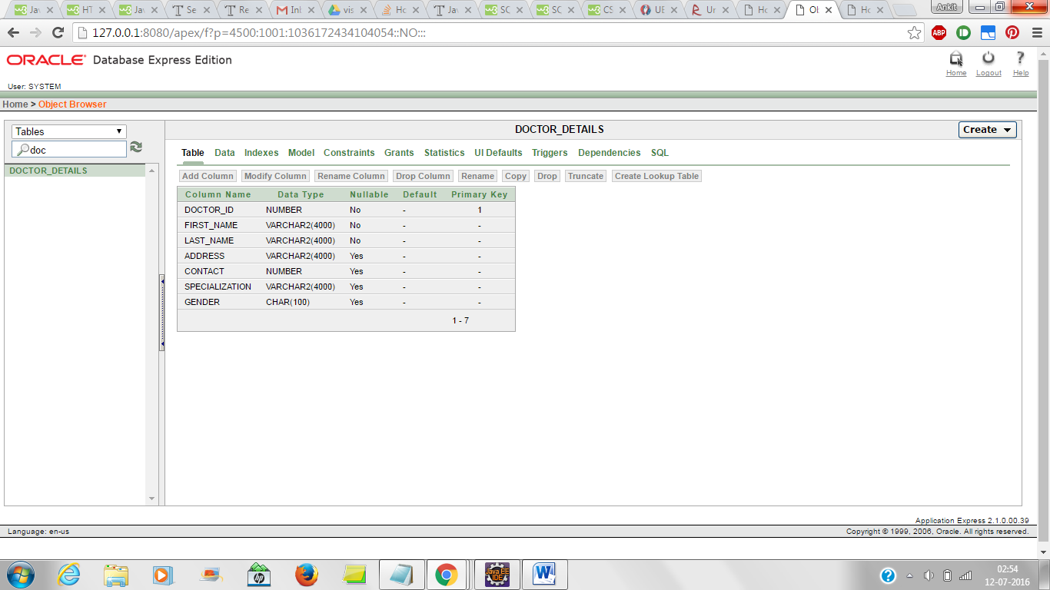

**- Appointment details**

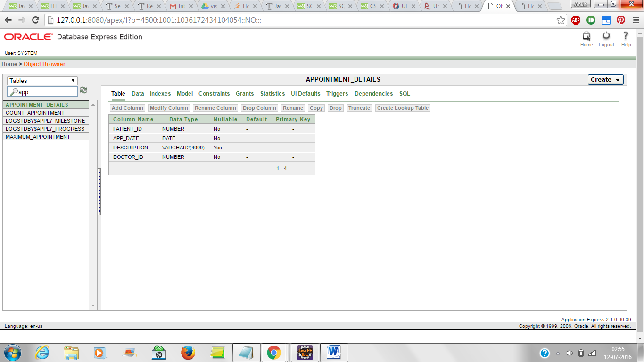

**- Maximum Appointments**

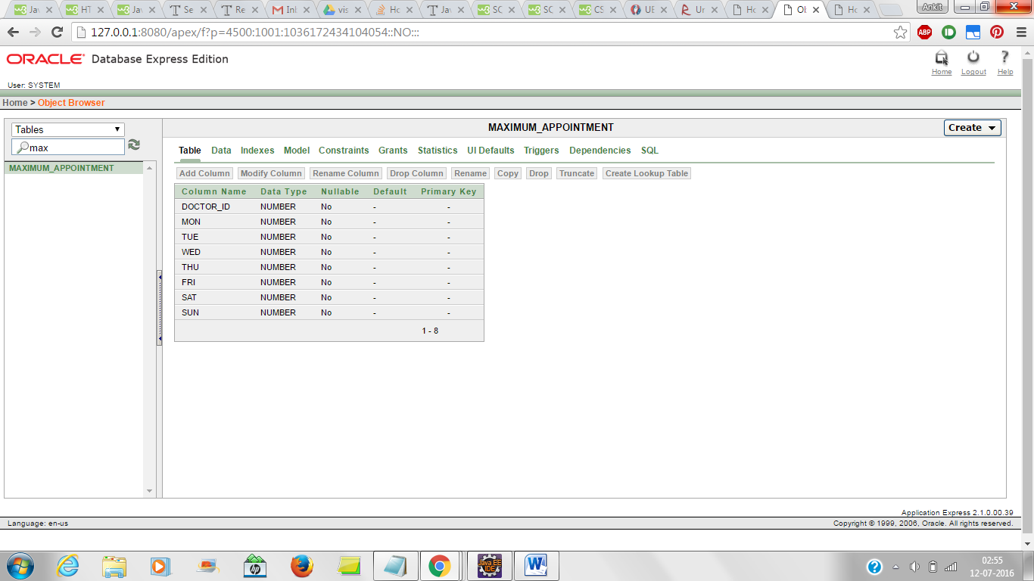

**- Count Appointment**

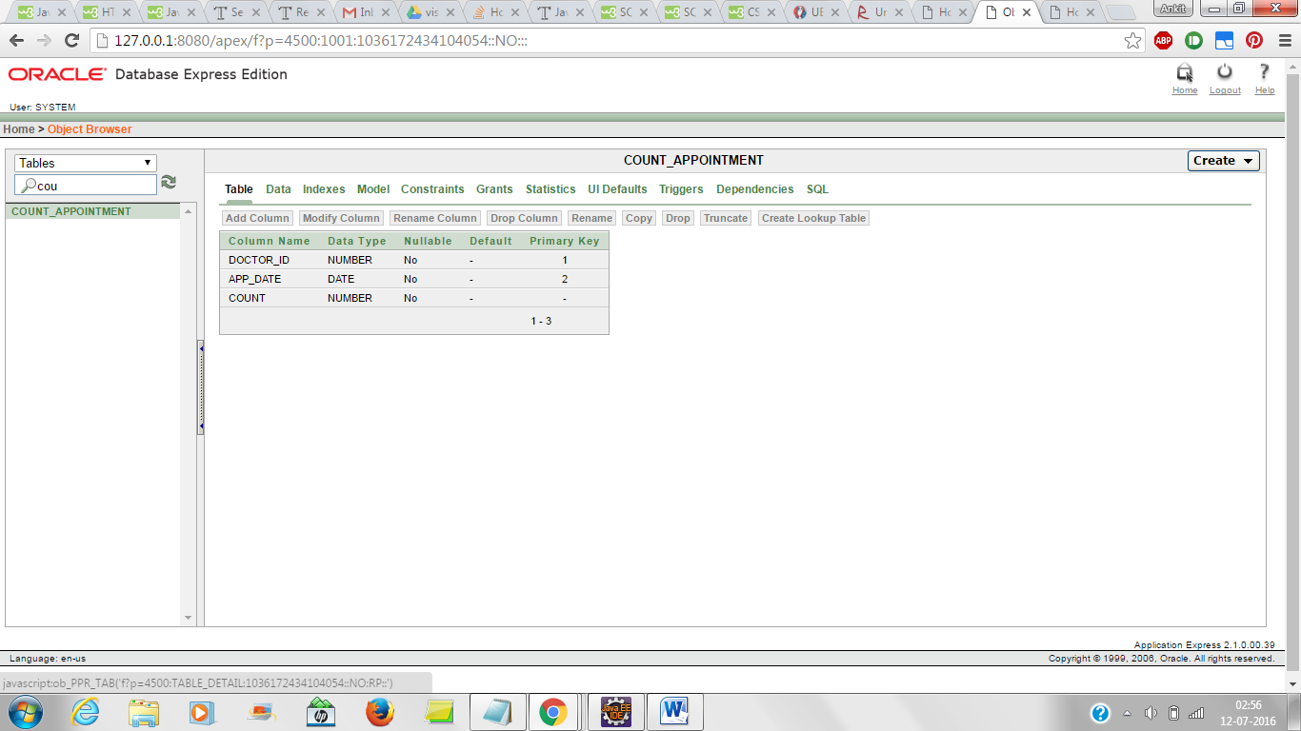

**- Daily Appointments**

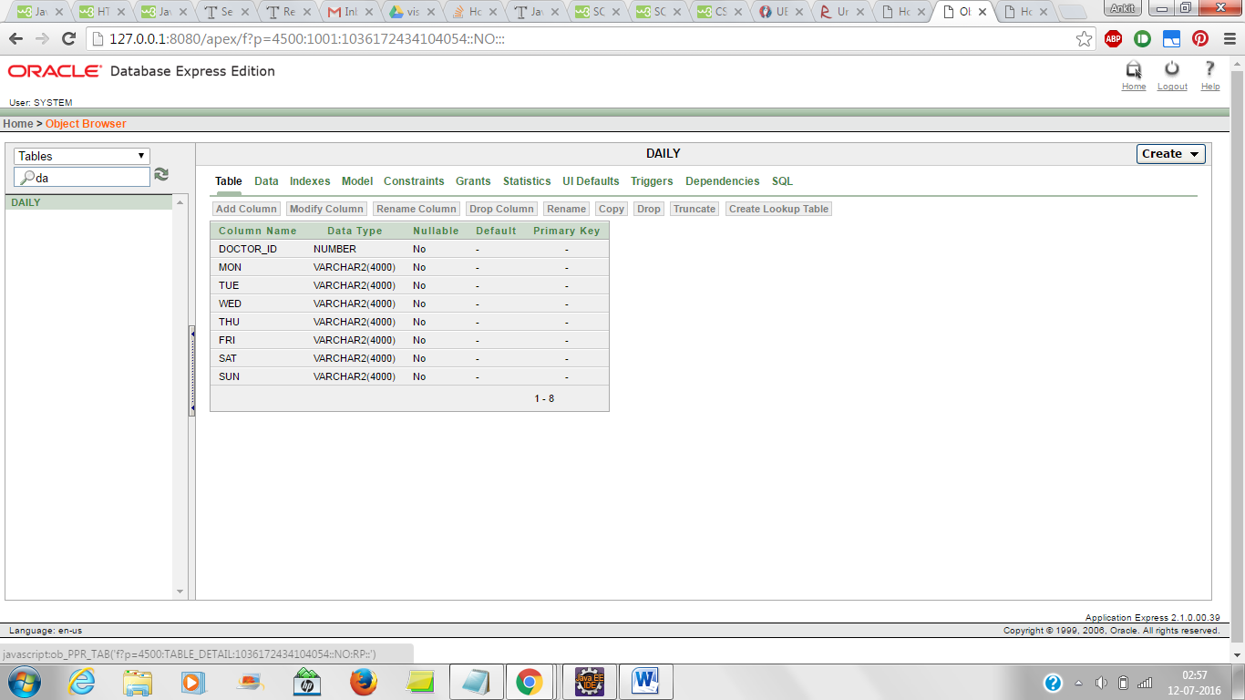

**4. DIAGRAMS**

* **Level 0 Data Flow Diagram**

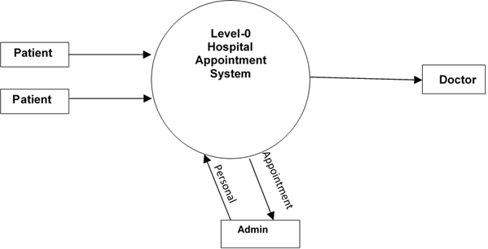

* **Level 1 Data Flow Diagram**

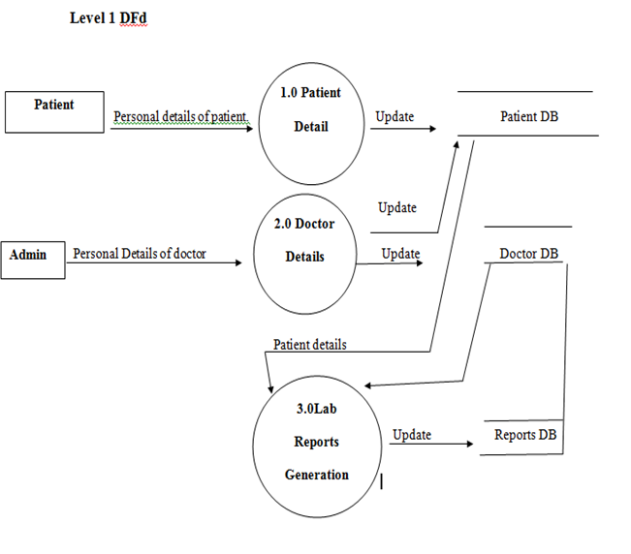

* **Use Case Diagram**

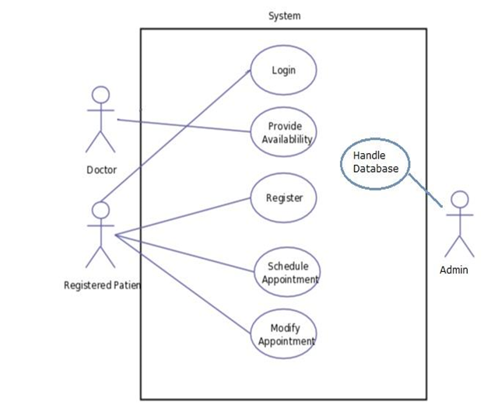

* **Class Diagram**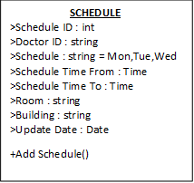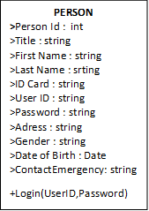

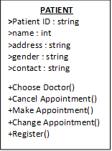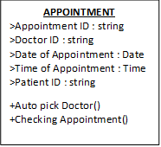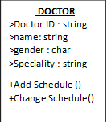

* **ER Diagram**

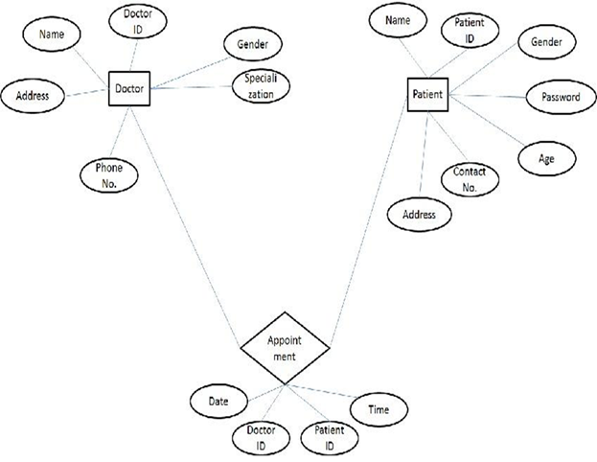

**5. TEST CASES**

**User :** The user is the patient who will register himself with the System with his unique Adhaar Card number. He can book, view and cancel appointments with the doctor at his convenience.

**Admin :** The admin would be able to view all the appointments, that have been booked, in the form of tables.

**6. SCREENSHOTS**

* **Home Page**

The Home Page has four buttons namely

* New Patient Register
* Existing Patient Login
* Book an Appointment
* View/Cancel Appointment

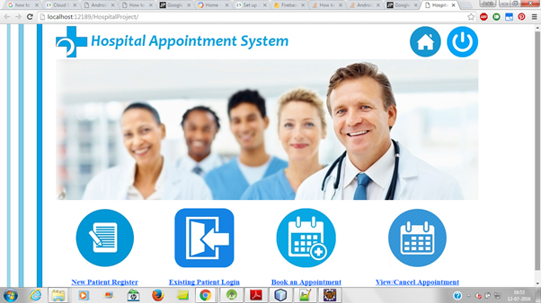

* **Registration**

On clicking in the New Patient Register, a new user will be taken to the Registration form where

Personal Information will have to be filled in the mentioned fields. Patient ID will be the Adhaar

Card number of the user. Mandatory fields have to be filled to complete registration.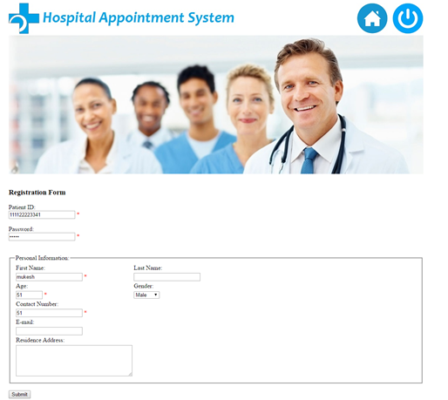

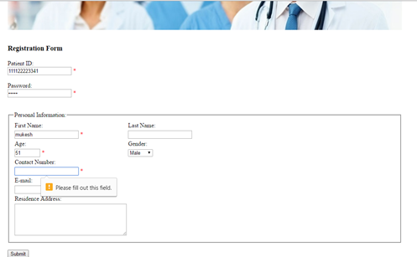

* **Registration Confirmation**

A dialog box ‘Registration Successful’ appears after the user clicks on the submit button, hence

confirming his registration.

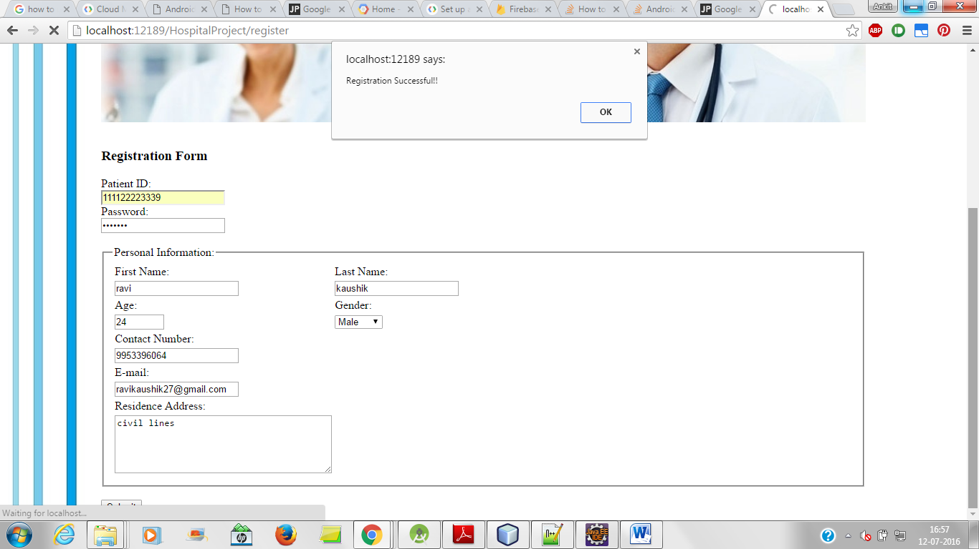

* **On entering wrong password**

On entering wrong password a dialog box appears asking the user to try logging in again with

correct password

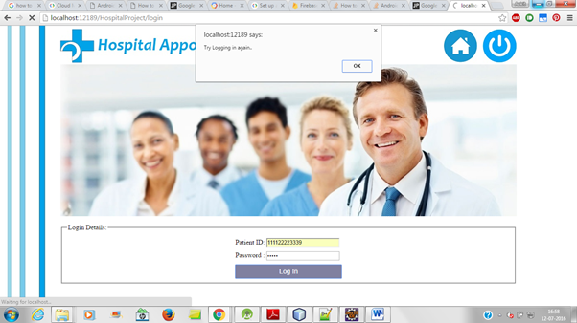

* **Successfull login**

On entering the correct password a dialog box appears, notifying successful login

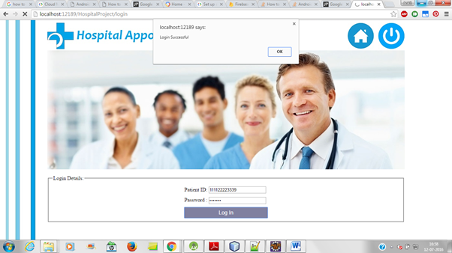

* **Doctor Selection**

The patient can select doctor from a drop down list

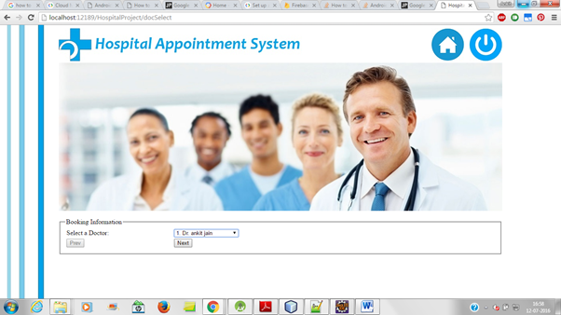

* **Date selection**

Date of appointment can be selected from a list of available dates

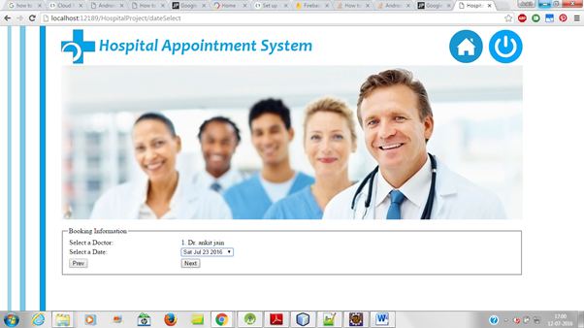

* **Describing Purpose of visit**

Disease has to be mentioned in the Description field

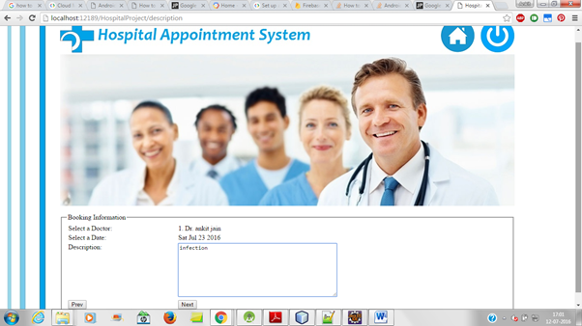

* **Confirmation of Appointment**

On clicking the Next button, a dialog box appears stating ‘Booking Successful’

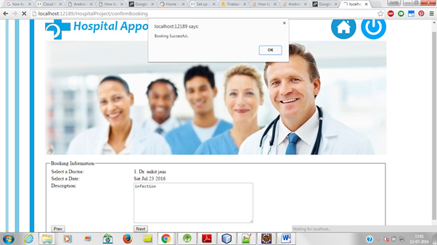

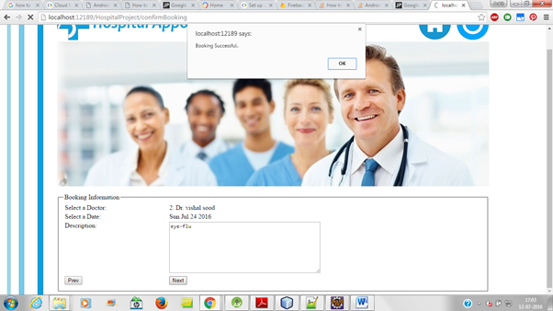

* **View Appointment**

Pre-Booked appointments can be viewed by patients.

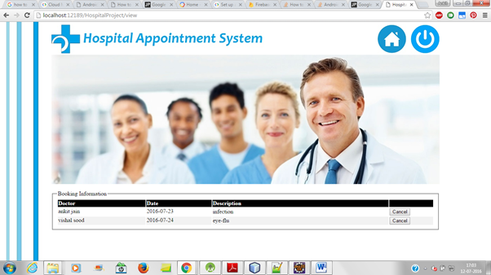

* **Cancelling appointment**

Pre- booked appointments can be cancelled by clicking on the Cancel button in the appointment

table .

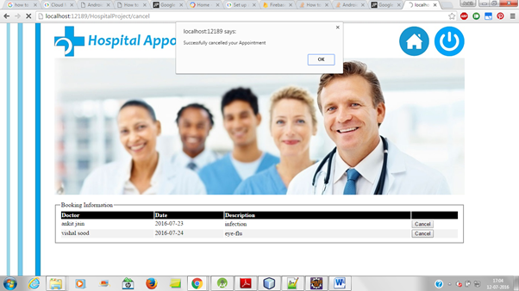

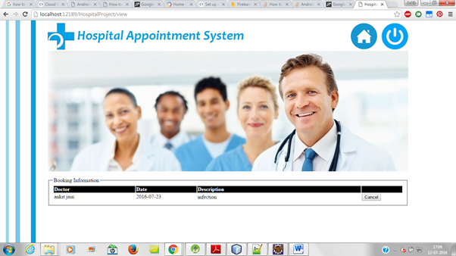

**7. FUTURE ENHANCEMENTS**

Following are a few future developments this project can go through in order to provide a better experience to the user:

* This project has not taken into consideration the validity of the Adhaar Card number given by the user. Though in the future, the system can associate with the UIDAI to verify with the user of the Adhaar Card number.
* Patients can get their lab results and health reports through this section which is available under each patient homepage.
* When documents will be made available under this module, a special notification symbol would appear above, to notify the patients.
* The hospital and the diagnostic clinics can further upload the reports of the patients on their account itself without having the user collect the reports from the hospital.

**8. SOURCES**

* www.google.com
* <http://www.aiims.edu>